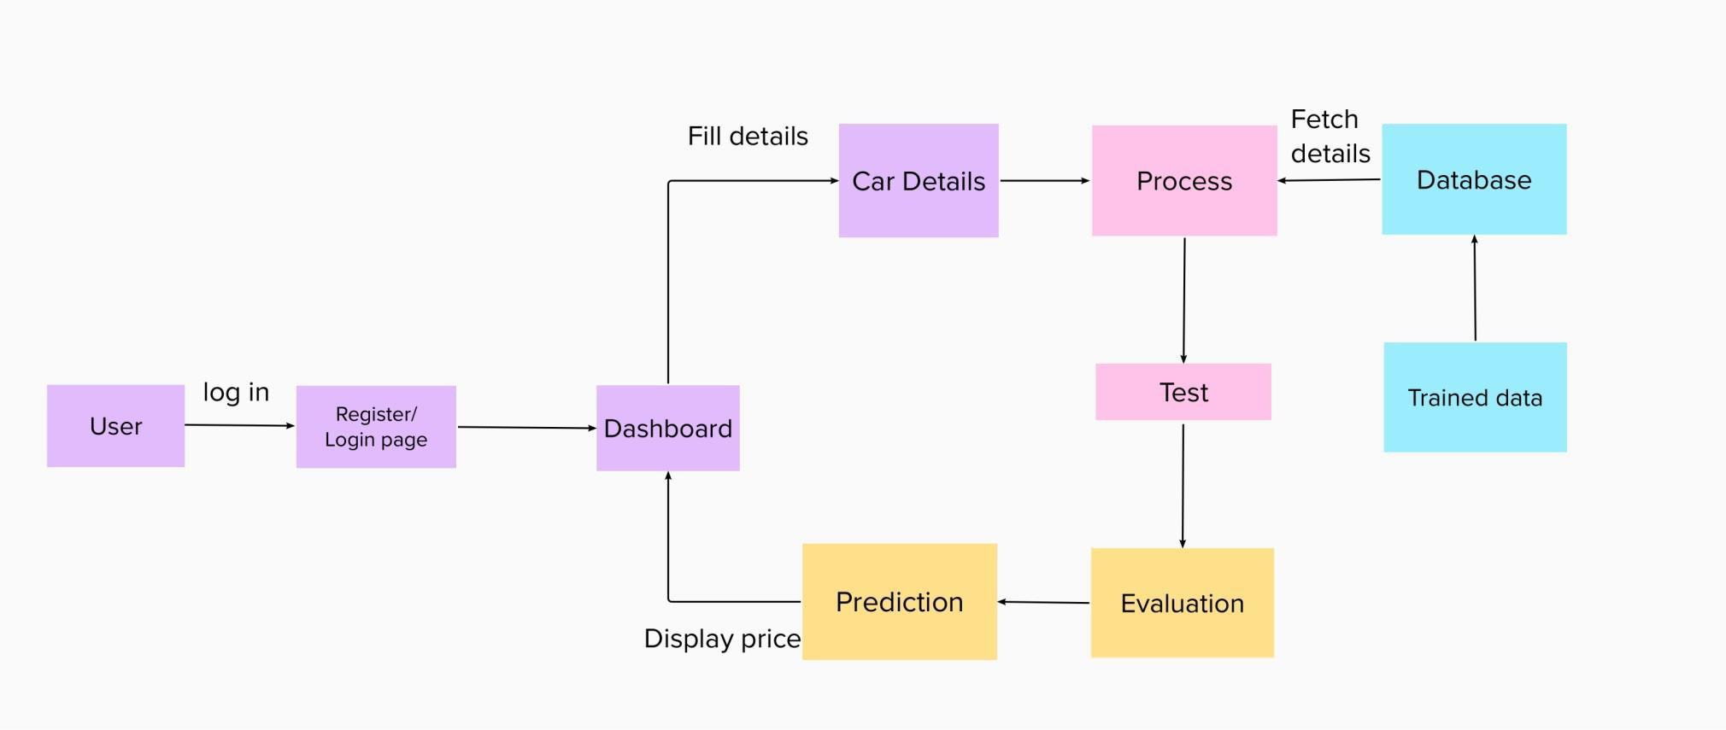

# UserStories

*Use thebelowtemplatetolistalltheuser storiesfortheproduct.*

| ***UserType*** | ***FunctionalRe***  ***quirement (Epic)*** | ***User StoryNumb er*** | ***UserStory/Task*** | ***Acceptancecriteria*** | ***Priority*** | ***Release*** |
| --- | --- | --- | --- | --- | --- | --- |
| *Customer (Webuser)* | *Registration* | *USN-1* | *Asauser,Icanregisterfortheapplicationby*  *enteringmyemail,password,andconfirmingm ypassword.* | *Icanaccessmyaccount/das hboard* | *High* | *Sprint-1* |
|  |  | *USN-2* | *Asauser,I willreceiveconfirmationemail onceIhaveregisteredfortheapplication* | *Icanreceiveconfirmation email&clickconfirm* | *High* | *Sprint-1* |
|  |  | *USN-3* | *Asauser,Icanregisterfortheapplicationthro ughmobilenumber* | *Icanregister&accesstheda*  *shboardusingmobile number* | *Medium* | *Sprint-1* |
|  |  | *USN-4* | *Asauser,Icanregisterfortheapplication throughGmail* | *Icanregister&accessthe dashboard* | *Medium* | *Sprint-1* |
|  | *Login* | *USN-5* | *Asauser,Icanlogintothe applicationby enteringemail&password* | *Icanaccessthe dashboard* | *High* | *Sprint-1* |
|  | *Dashboard* | *USN-6* | *Asauser,Ican visitthehomepage* | *Icaneditmyprofile* | *Medium* | *Sprint-1* |
|  | *Cardetails* | *USN-7* | *Asauser,Ishouldgivethecardetailslikecarmode l,engineandfuel type, etc…* | *Ishouldthegivecard etails* | *High* | *Sprint-2* |
|  | *CarPrice* | *USN-8* | *Asauser,Icanviewthecurrentrate of the usedcarprice* | *Iknowthecar price* | *High* | *Sprint-4* |
| *Admin* | *ModelBuilding* | *USN-9* | *Asan admin,Ishouldtrain andtestthegiven dataset* | *Icanbuildthetrainand testmodel* | *High* | *Sprint-3* |
|  | *PredictionChart* | *USN-10* | *Asanadmin,Ishould sendtheprediction chartandthenearestservicecentrelocation* | *Icanprovidechart* | *Medium* | *Sprint-3* |
|  | *Predict* | *USN-11* | *Asan admin,I willpredicttheprice* | *Icanpredictthecarprice* | *High* | *Sprint-4* |